Homophones (CW)
Week:2 Day:1 Grade: 4
Homophones are the words that have same sounds but different meanings and spellings.
Example : Son-Sun , Meat-Meet
Q: Complete the following sentences by writing the correct homophone from the brackets. Use the other word in your own sentence.
- Prime minister Imran Khan was interviewed in his hotel ____________. (sweet/suite)
___________________________________________________________
- It’s a huge window made from a single____________ of glass. (pain/pane)
___________________________________________________________
- We could hear the ____________ of the wounded soldiers. (grown/groan)
___________________________________________________________
- Before going to bed, we daily listen interesting ____________ from Granny. (tales/tails)
___________________________________________________________
5. These shoes hurt my____________. (toes/tows)
___________________________________________________________
6. He will have to ____________ the video to attend the call. (paws/pause)
___________________________________________________________
Synonyms(CW)
Week:2 Day:3 Grade4
Q: Rewrite the following sentences and replace the underlined word with its synonym.
1. The painter blended red, orange and purple color perfectly.
__________________________________________________________
2. My room mates always assist me in completing my assignments.
__________________________________________________________
3. It was amazing to meet her after four years.
__________________________________________________________
4. He answered my email after a few week.
__________________________________________________________
5. The government announces the scholarships annually.
__________________________________________________________
6. He has a collection of ancient stamps.
__________________________________________________________
7. My teacher commanded me to close the window.
__________________________________________________________

8. They were scared by the rattling of windows.
__________________________________________________________
9. Sania’s new born brother was quite skinny.
__________________________________________________________
10. I didn’t display my sadness in front of my family.
__________________________________________________________

Week: 2 Grade: 4 Day:4 HW
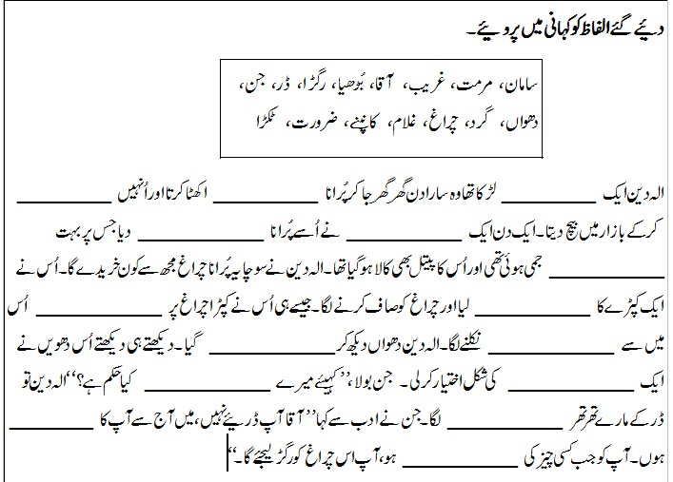

Week:2 Grade:4 Day:2 CW
تفہیم بک لیٹ میں کیجئے۔
۱۔کسی ایسی کتاب کا نام بتائیے جو آپ کو تحفے میں ملی ہو۔
۲۔آپ کو تحفے میں کیا کیا چیزیں لینا پسند ہیں؟ اور کیوں؟
۳۔دئیے گئے الفاظ کے معنی تحریر کیجئے۔
الفاظ
۱۔ قید
۲۔ بہترین
۳۔ لازمی

Grade 4 Week 2 Date: 7-12-2020 Homework

- Find all the common factors of each pair of numbers.

a) 6 and 18 b) 12 and 16

c) 9 and 27 d) 10 and 25

e) 18 and 21 f) 28 and 36

g) 14 and 42

