Week :3 Subject: Maths Grade: 2
Date | Day | Topic | Resource | CW | HW
14-12-2020 | Mon | Volume  Ch-15 | M.E.P booklet + online worksheet | Introduction to Volume  M.E.P booklet Pg.28(Q2) and Pg. 30 (Q5) | 1. Attempt Pg.29 (Q3) in M.E.P booklet.  2. Copy and complete multiplication sums in your H.W copy. (worksheet attached)
15-12-2020 | Tues | Volume  Ch-15 | Activity guidance by the teacher + M.E.P booklet + textbook | Concept of more or less than 1 liter.  Note: 1 spoon, 1 paper cup, 1 jug, 1 liter water bottle filled with water is needed.  M.E.P booklet Pg. 28(Q1) | 1. Attempt Pg. 260(Q2 and Q4) and Pg. 262 in the textbook.  2. Draw any picture with at least 3 basic shapes in your H.W copy.
16-12-2020 | Wed | Volume  Ch-15 | M.E.P booklet + textbook | Measuring volume in liters  (Word Problems)  M.E.P booklet Pg.29-30 (Q4) (i, ii) | Name and draw any 4 types of container in which you can keep the given volume.  One has been done for you.  (Maths H.W copy)
  Container | Name of container | Volume
  1.  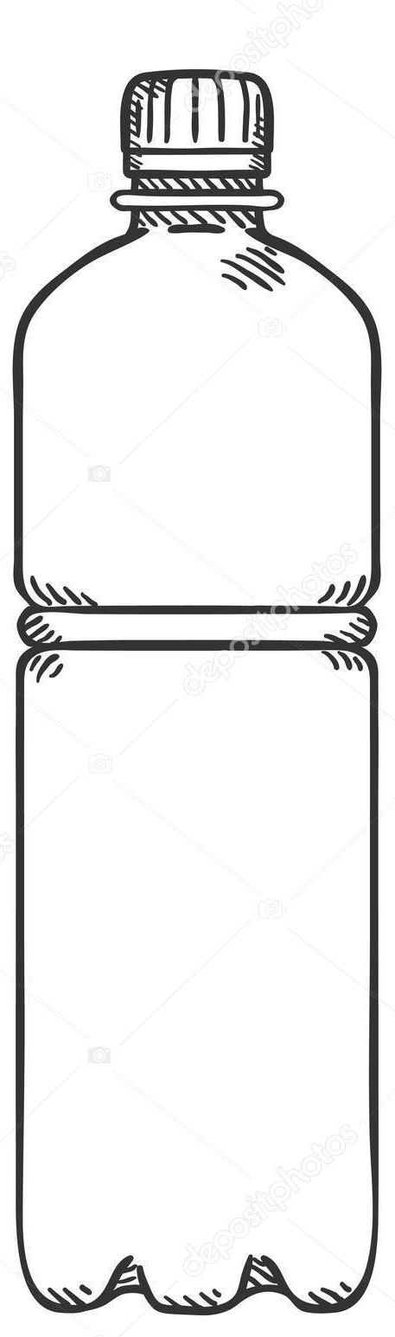 | Bottle | 1 liter
  2. |  | 5 liter
  3. |  | 3 liter
  4. |  | Less than 1 liter
17-12-2020 | Thurs | Length | Activity guidance by the teacher | Measuring the length with the help of scale.  Note: A scale with proper cm marked on it, bandage, pencil, comb and spoon are required.  M.E.P booklet Pg. 21 | Draw, measure and write the lengths of the given objects in your maths H.W copy.
  Objects | Lengths
  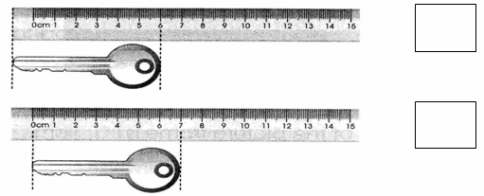
  Key
  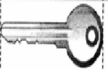
  Pencil
  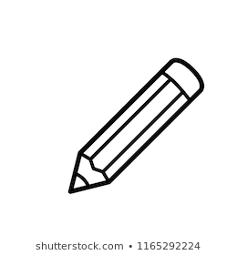
  Eraser
  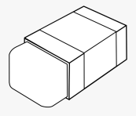
  
  Sharpener

Week: 3 Subject: Science Grade: 2
Date | Day | Topic | Resource | CW | HW
14-12-2020 | Mon | - Uses of Plants | - Textbook | - Discussion of book Pg.25.  - Written work Q1 and Q2. | - Read book Pg.26.  - Do Ex1 on book Pg.29 in book.
15-12-2020 | Tue | -- | -- | - Discussion of book Pg.26.  - Book work: Q6 on Pg.31 in book.  - Written work Q3 and Q4. | - Read book Pg.27.  - Attempt Ex 2 and Ex 3 on book Pg.29 and 30 in book.
16-12-2020 | Wed | -- | -- | - Discussion and concept check of book Pg.27.  - Written work: Q5 to Q7. | - Complete Ex 4 on book Pg.30 in book.
17-12-2020 | Thurs | -- | -- | - Written work: Q8 to Q10. | - Do Q5 on book Pg.30 in copy.

Week:3 Subject: Urdu Grade:2
Date | Day | Topic | Resource | CW | HW
14-Dec-20 | Mon | تفہیم | تفہیم بک لیٹ | صفحہ نمبر :۱۵ | تفہیم بک لیٹ میں کام  صفحہ نمبر ۱۵ مکمل کیجیے۔  اگلے صفحہ پر تفہیم کی خوشخطی کیجیے اور درخت کی تصوریر بنا کر رنگ بھرئیے۔
15-Dec-20 | Tues | تھا، تھی، تھے | قواعد کاپی  Online Exercise | تھا، تھی، تھے کے جملے | تفہیم کاپی میں تھا، تھی، تھے کے دو دو جملے بنائیے۔
16-Dec-20 | Wed | تخلیق | تخلیق بک لیٹ | صفحہ نمبر:۷ سوال نمبر:۱ | صفحہ نمبر ۷ مکمل کیجیے۔
17-Dec-20 | Thurs | ختمہ یا سوالیہ | قواعد کاپی  Online Exercise | جملوں کے آخر میں ختمہ یا سولایہ کا نشان لگائیے۔ | ورک شیٹ میں دیے گئے جملوں کے آخر میں ختمہ یا سوالیہ نشان لگائیے۔

Grade:2 Subject: Islamiyat Week: 3
Date | Day | Topic | Resource | CW | HW
16-12-2020 | Wed | Allah | Textbook | - Verbal Sessions: “Insha Allah” Reading , translation and use (pg.7)  - Reading and Understanding (pg.8)  - Written work: Ex1 part a-b on pg.10 | Learn the translation of Insha Allah on pg.7
17-12-2020 | Thurs | Allah | Textbook | - Verbal Session: Masha Allah and Subhan Allah with translation and use (pg.7)  - Reading and Understanding pg.9  - Written work: Ex 1 part c on pg.10 | - Attempt Ex 1 part d and e on pg.10 in the book.

Week: 3 Subject: English Grade: 2
Date | Day | Topic | Resource | CW | HW
14th  Dec | Mon | Language Skills | QR+ Online Ex | Prepositions in sentences. (in, on, in front of, back, under). (CW Ex is attached) | Attempt in comprehension copy.  Q. Make 4 sentences using the following prepositions. in – on – under – front
15th Dec | Tues | Paragraph writing  Punctuation | CWB + Online Ex | - CWB pg.7 Q1  - Punctuation (Do the attached CW Ex in grammar copy) | - Do CWB pg.7 Q2  - Write a few lines about ‘Winter Season’ in grammar copy. Also draw and color some things we use in winter to keep us warm.
16th Dec | Wed | Language Skills | Online Ex + QR | Identify adverbs and adjectives in sentences. (CW Ex is attached) | Do the following in comprehension copy.  Q. Make sentences using following adjectives.  1. Beautiful 2. Healthy 3. Naughty
17th Dec | Thurs | Comprehension | Comprehension Booklet | CB pg.10 | - Attempt CB pg.11 (Additional Questions)  Q1. Who is the tallest in your family?  Q2. Who teases you the most in your house?

